**JOHARI WINDOWS**

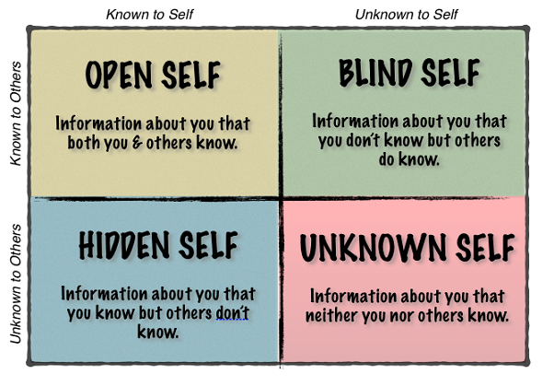

HIDDEN

UNKNOWN

BLIND

OPEN